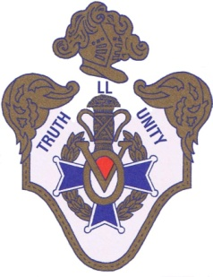 | VASA ORDER OF AMERICA  A Swedish-American Fraternal Organization  LOCAL LODGE SVEA NO. 296  Instituted May 20, 1914  Erie, Pennsylvania
Hälsningar!
You are cordially invited to the Local Lodge SVEA #296 annual banquet. Join us as we commemorate 109 years of service – I Sanning Och Enighet - In Truth and Unity.
Zem Zem Shrine Club
The Living Room
2525 West 38th Street, Erie, PA 16506
Sunday, May 21, 2023 at 12:30PM

This is a buffet luncheon menu that will include sliced roast beef, stuffed chicken breast, baked white fish, roasted potatoes, and salad. Coffee and water will be available on the tables. Other beverages can be purchased from the bar.
The cost is $27/person (includes appetizer, dessert, tax and gratuity) with money and reservations due no later than May 14th. You may register on line through our website: www.svea-erielodge.org. Or mail reservation and check, payable to SVEA #296, along with the bottom form, mailed to:
Martha Stickner 1366 W. 34th Erie, PA 16508
Call Pat, 814-528-5675 or Martha, 814-602-5984 with questions.

We’ll be joining the Festivities:

Name/s:_________________________________________________________ # of guests______
Total $ enclosed:__________

