Sjölunden is a cultural immersion experience where the counselors speak only Swedish. Small class groups meet every day to learn Swedish (including vocabulary and grammar). Traditional music is a large part of the exposure to Swedish culture. Students learn songs and expand their vocabulary. They also participate in traditional feasts such as Midsommar and Lucia. Several art classes, for example weaving, fabric printing, and dalmålning are offered. Preparation (and eating!) of Swedish traditional foods is also part of the experience.
We have received rave reviews from past scholarship winners, several of whom have gone back for another session either as a Grand Lodge recipient, or even on their own. It has been a great experience for all of them.
Sjölunden offers two youth immersion camps in 2020, each for two weeks: July 13-25 for ages 8-14 and July 27-August 8 for ages 10-18. The scholarship covers the entire tuition cost of $2,200. Application forms with a list of additional information required from each applicant can be obtained from the Secretary of your local Lodge. Applications must be postmarked no later than February 29, 2020.
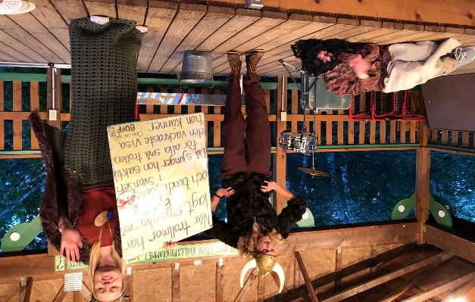
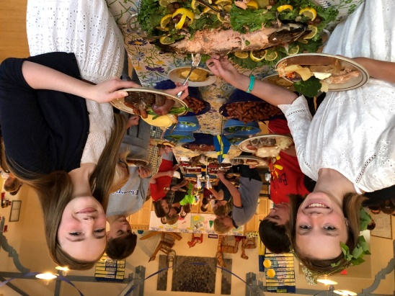
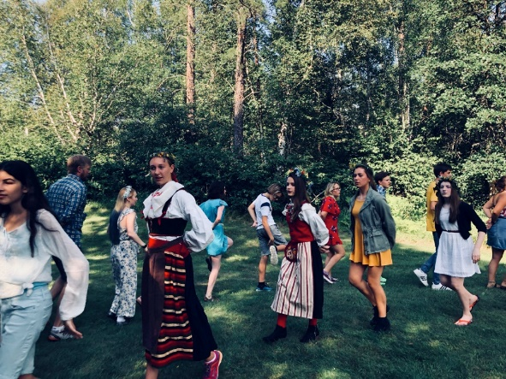
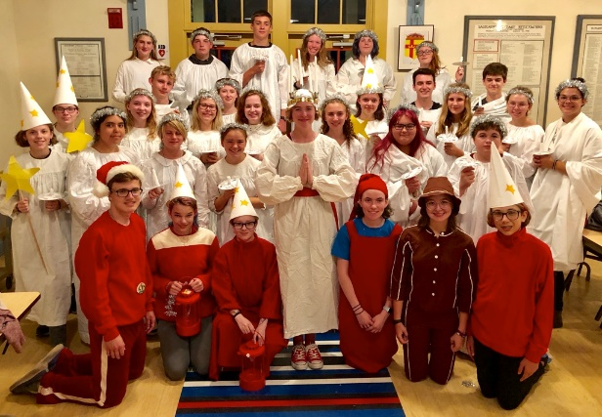
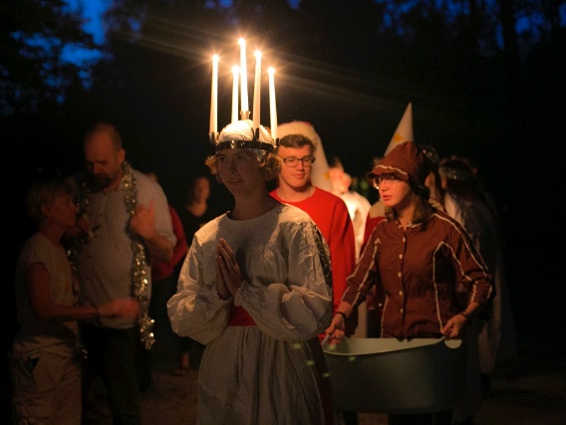
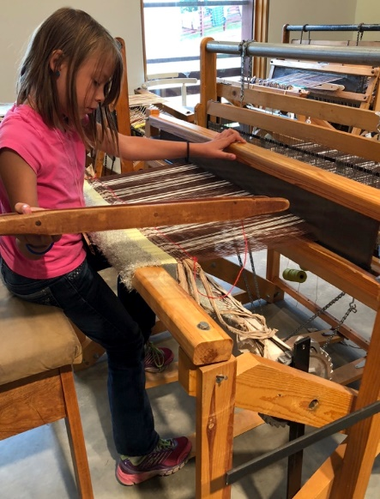
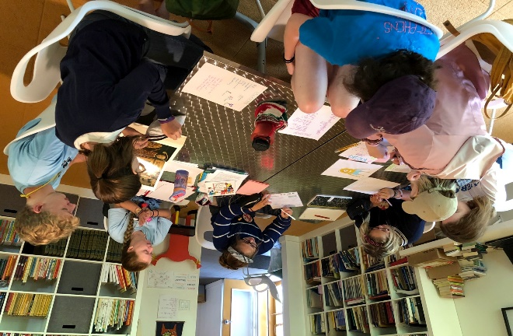
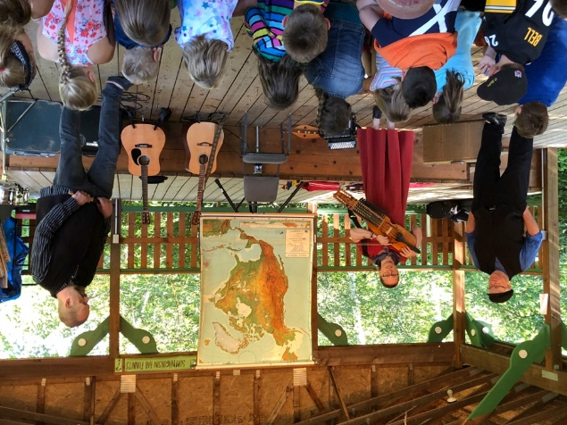
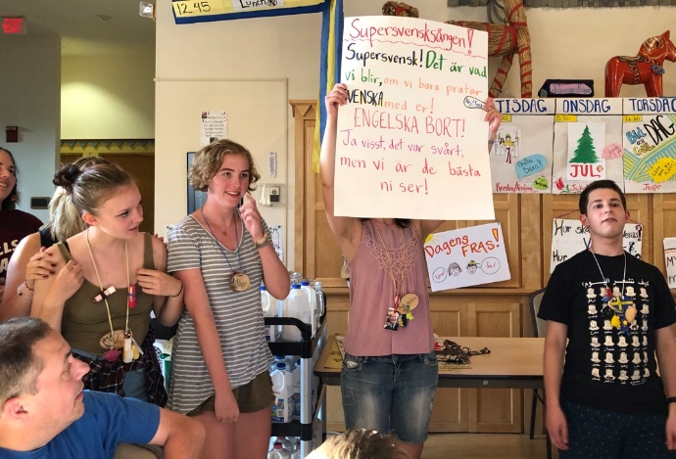
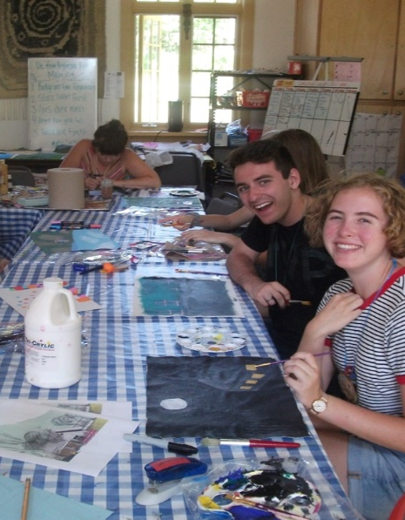
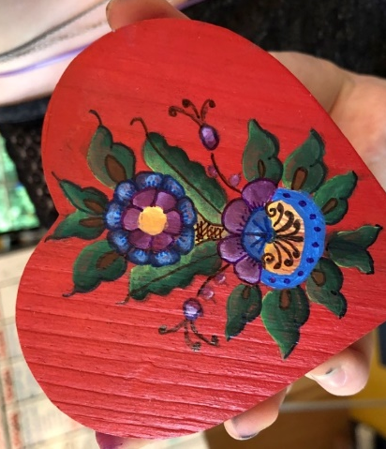
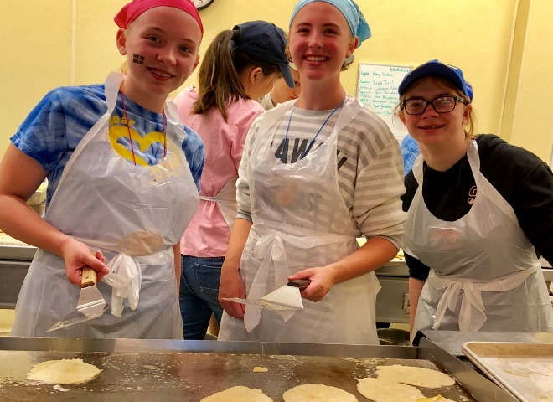

YOUTH LANGUAGE CAMP SCHOLARSHIP
Swedish Immersion Language Camp at Sjölunden,
Concordia Language Villages, Bemidji, MN

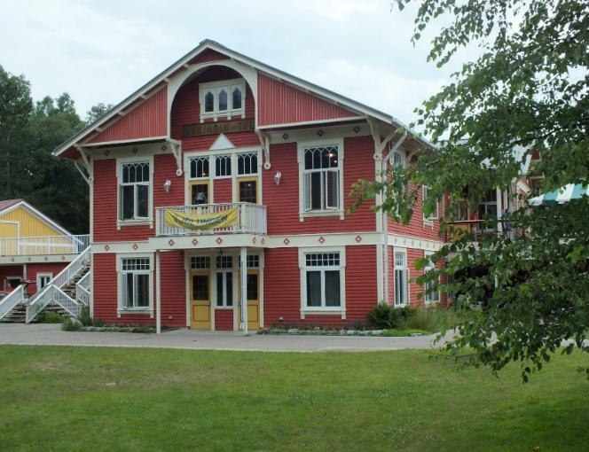

Since 1961 Concordia College has offered cultural immersion programs in the north woods of Minnesota for participants to develop language proficiency.
District Lodge Pennsylvania No. 9 of the Vasa Order of America is again offering a YOUTH Language Camp Scholarship to Concordia Language Villages in 2020. It is open to all children or grandchildren of members of your Lodge between the ages of 8 and 18. The sponsoring Vasa member must have been a member for two years as of January 1 of 2020.

